Civil war in Liberia

UNSC Resolution: | 950
Date of adoption: | 21-Oct-1994
Operative paragraph: | 10
Demand number: | 950,1011

Sarah-Myriam Martin-Brûlé

Wording of demand

Cooperate fully in creating the conditions necessary for the delivery of humanitarian assistance to all in need in Liberia

List of addressees of the demand

National Patriotic Front of Liberia, Government of Liberia, Lola Defence Force, Liberian Peace Council, United Liberation Movement of Liberia for Democracy - Krahn, United Liberation Movement of Liberia for Democracy - Mandingo

Short-term compliance

Description of the addressee(s)’ conduct

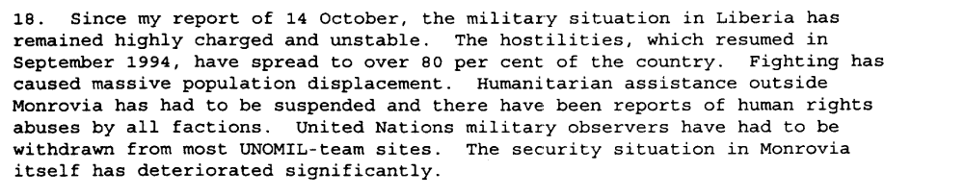

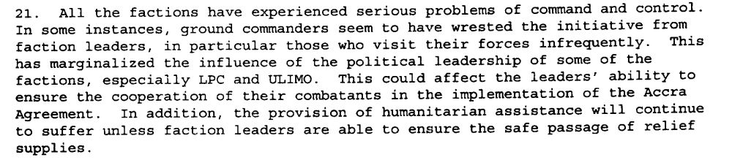

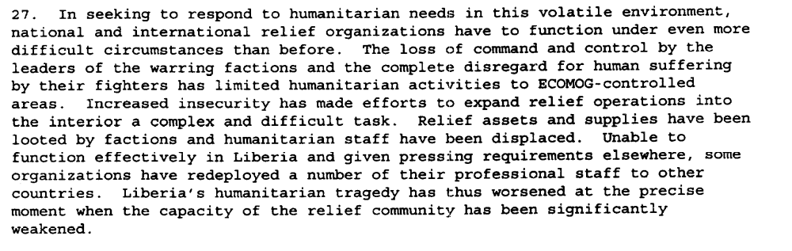

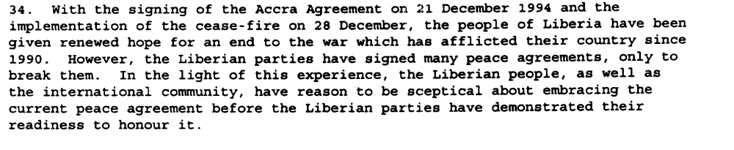

Eight Progress Report of the Secretary-General on the United Nations Observer Mission in Liberia, S/1995/9, 6 January 1995

Assessment

Short-term compliance
X No or marginal compliance (1) | Medium low compliance (2) | Medium high compliance (3) | Full or almost full compliance (4)

Considerations underlying the assessment

During the six months following the adoption of the resolution there were stark evidence that the demand addressees did not cooperate fully in creating the conditions necessary for the delivery of humanitarian assistance to all in need in Liberia.

Medium-term compliance

Description of the addressee(s)’ conduct

The Secretary-General reported that military activities had intensified throughout
the country and the overall situation had further deteriorated. The civilian population
continued to suffer and the factions’ military activities had impeded the delivery of
essential relief items to most areas of the country.

http://www.un.org/fr/sc/repertoire/93-95/CHAPTER%208/AFRICA/item%2005-%20Liberia.pdf

“By the end of 1995, following some initial progress in the implementation of the peace agreements and improvement in the security and humanitarian conditions in the country, the situation in Liberia began to take another turn for the worse. The implementation of the Abuja Agreement was behind schedule. The critical aspects of the Agreement, disarmament and demobilization, did not begin at the time foreseen. There were serious violations of the ceasefire. These violations included intermittent fighting between Alhaji Kromah's forces (ULIMO-K) and Roosevelt Johnson's forces (ULIMO-J). Fighting also occurred between LPC and NPFL and between NPFL and ULIMO-K. There were also delays in deploying ECOMOG personnel and equipment throughout the country. At the end of December 1995, heavy fighting broke out at Tubmanburg as a result of attacks on ECOMOG by ULIMO-J troops. Casualties were suffered by the combatants and by the civilian population.
In this volatile atmosphere, following confrontations between rival groups within ULIMO-J, the transitional government, on 23 March, issued a warrant for the arrest of General Roosevelt Johnson, accusing him of murder. On 6 April, the Rapid Reaction Unit of the national police, backed up by the forces of NPFL and ULIMO-K, attempted to arrest him forcibly. They were attacked by General Johnson's forces, supported by fighters from AFL.
The fighting was accompanied by the complete breakdown of law and order in Monrovia. Fighters from all factions systematically looted the commercial district as well as United Nations offices and warehouses. Houses were broken into, buildings were set on fire and vehicles were commandeered.
Civilians were caught in the crossfire. More than half of Monrovia's 1.3 million citizens were displaced, with many thousands concentrated in several locations in an attempt to escape the fighting. Thousands of others sought refuge in neighbouring countries.
UNOMIL and the United Nations agencies were forced to relocate all non-essential personnel to neighbouring countries or to repatriate them.”
http://www.un.org/Depts/dpko/dpko/co_mission/unomilFT.htm#DECEMBER

Assessment

Medium-term compliance
X No or marginal compliance (1) | Medium low compliance (2) | Medium high compliance (3) | Full or almost full compliance (4)

Considerations underlying the assessment
Within the two years following the adoption of the resolution, there were many evidence that the demand addressees did not cooperate fully in creating the conditions necessary for the delivery of humanitarian assistance to all in need in Liberia.

Depth of demand

Assessment

Level of depth of demand
Low depth of demand (1) | X Medium depth of demand (2) | High depth of demand (3)

Considerations underlying the assessment

Given the anarchic context in which the parties found themselves, compliance with this demand would have made it significantly more difficult for some of the addressees to achieve victory. The looting and prey on United Nations and humanitarian personnel was used as a military strategy to gain power over the adversaries (deprive them of their civilian support base, send costly signaling of their intentions to win the war or to gain access\control over a territory, etc.).

Level of confidence about coding decisions

Level of confidence about coding decision
Extremely high | X High | Moderate

Comments to IPI (if any)

